Mobile Working Goes Pro with Sennheiser’s Premium Headsets and Speakerphones

Copenhagen/Barcelona, 21 February 2016 – With the rapid uptake of Unified Communications showing no sign of slowing, Sennheiser is bringing its suite of high performance contact center and office (CC&O) headset and speakerphone solutions for mobile business professionals to Mobile World Congress. The audio specialist will launch the new generation PRESENCE™ Mobile Series and demo its premium MB Pro Series and Speakerphone Series at the Showstoppers @ Mobile World Congress event on February 21 in Barcelona.

“Barcelona has long been the place where people have talked about the potential revolutions that mobile technologies will bring in the future. We are now living through one of these groundbreaking shifts, as the professional world pivots towards more agile working practices - where work is something you do, rather than a place you go,” explains Andreas Bach, President at Sennheiser Communications A/S.

“With this transformation has come a huge demand for professional end-point devices, such as headsets and speakerphones, to support the mobile work trend and at the same time ensure a natural, rich communication and collaboration experience”, says Bach.

Sennheiser has made significant investments in developing its professional contact center and office solutions to this end, and has experienced an exciting period of growth that has significantly outpaced the growing global market for CC&O headsets. Notably, an increasing proportion of Sennheiser’s success comes from unified communications (UC) solutions.

“We are seeing significant growth in the market for high quality, high performing headsets and speakerphone solutions for business professionals that need to access the full breath of UC capabilities anytime and anywhere. Our product portfolio is designed to empower businesses to thrive in sophisticated work environments and meet the growing expectations for better and more flexible workplace communication and collaboration based on excellent audio and design quality.”

Sennheiser’s ongoing push in the CC&O market reflects a recent analysis by Frost & Sullivan (Analysis of the Global Contact Center and Office Headset Market, 2015), which predicts that revenues from global contact center and office headset sales will follow a smooth growth curve, with expected compound annual growth rates (CAGRs) of 11.7 percent during 2014 - 2021. As enterprises turn to communications tools to drive productivity, Frost & Sullivan notes that UC headset sales have come to represent 36.4 percent of total CC&O headset revenue during 2015.

At Showstoppers @ MWC, Sennheiser will be presenting and demonstrating solutions targeted at this rapid-growth market, reflecting the audio specialist’s emphasis on delivering innovative products with superior sound quality, wearing comfort and quality design that enhance the unified communications experience. All UC variants are compatible with major UC and softphone brands and certified for Skype for Business on both Windows and Mac.

New Generation: PRESENCE™ Mobile Series
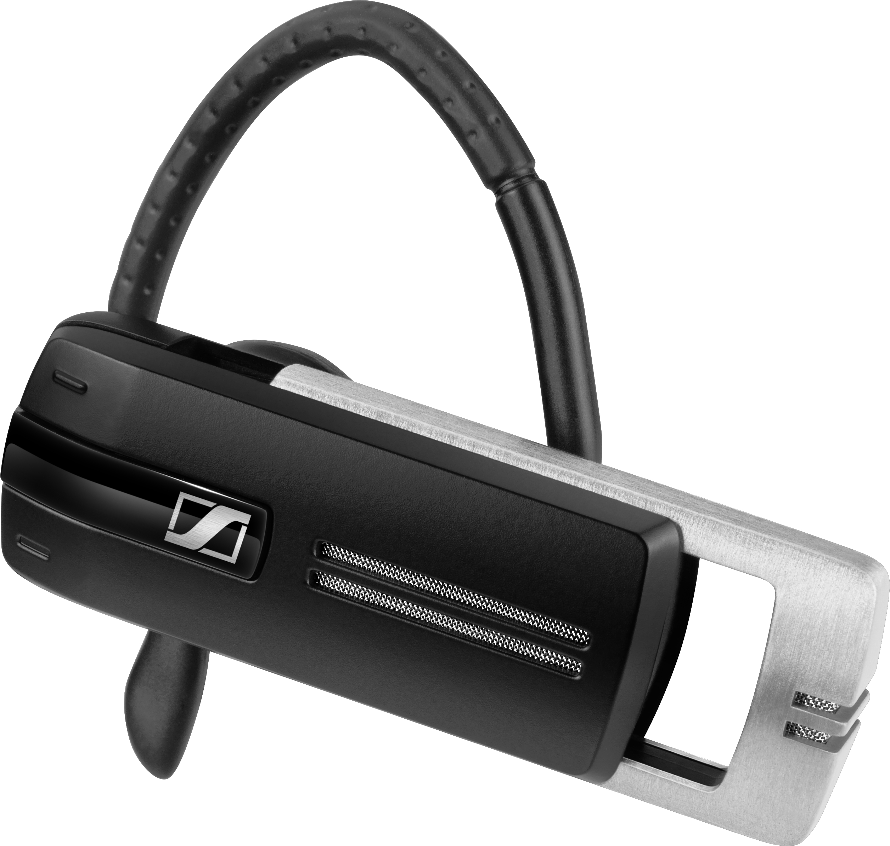
The enhanced PRESENCE™ Mobile Series offers a solution for business professionals requiring outstanding communication in even the most challenging sound environments. The new generation of models offers an even clearer communication experience due to enhanced noise filtering technologies. In addition, the headsets improve ease of use and flexibility with a wider choice of comfort-enhancing wearing styles.

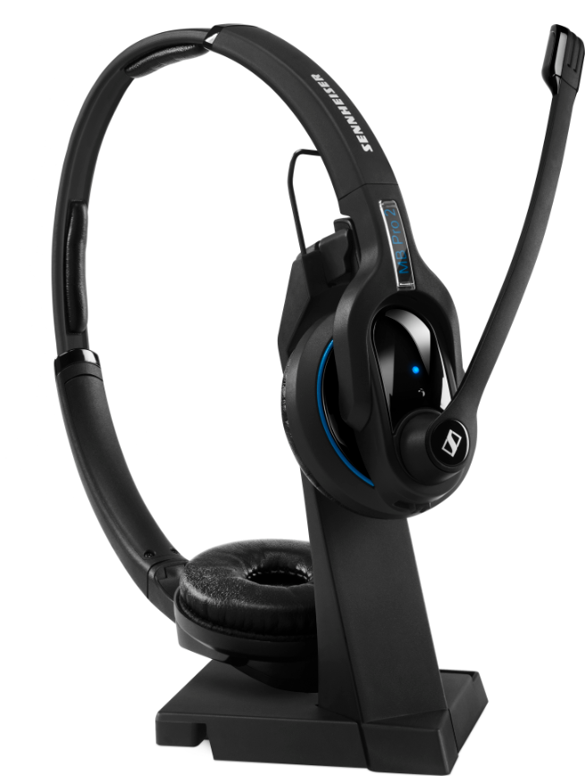
Mobile Business Pro Series (MB Pro)
Sennheiser’s MB Pro Series’ UC models, MB Pro 1 and MB Pro 2, are premium Bluetooth® headsets for UC business professionals that demand wireless communication freedom, brilliant sound quality, and exceptional wearing comfort. Equipped with an ultra noise-cancelling microphone, MB Pro UC headsets reduce background noise from sources such as roads or air conditioning fans for perfect speech transmission. Combined with Sennheiser HD sound and its unique Room Experience™ technology*, the MB Pro headsets provide listeners with a natural and more comfortable listening experience with less stress especially in noisy environments. High-quality robust design and large leatherette ear pads ensure exceptional wearing comfort and powerful sound.

Sennheiser’s Speakerphone Series
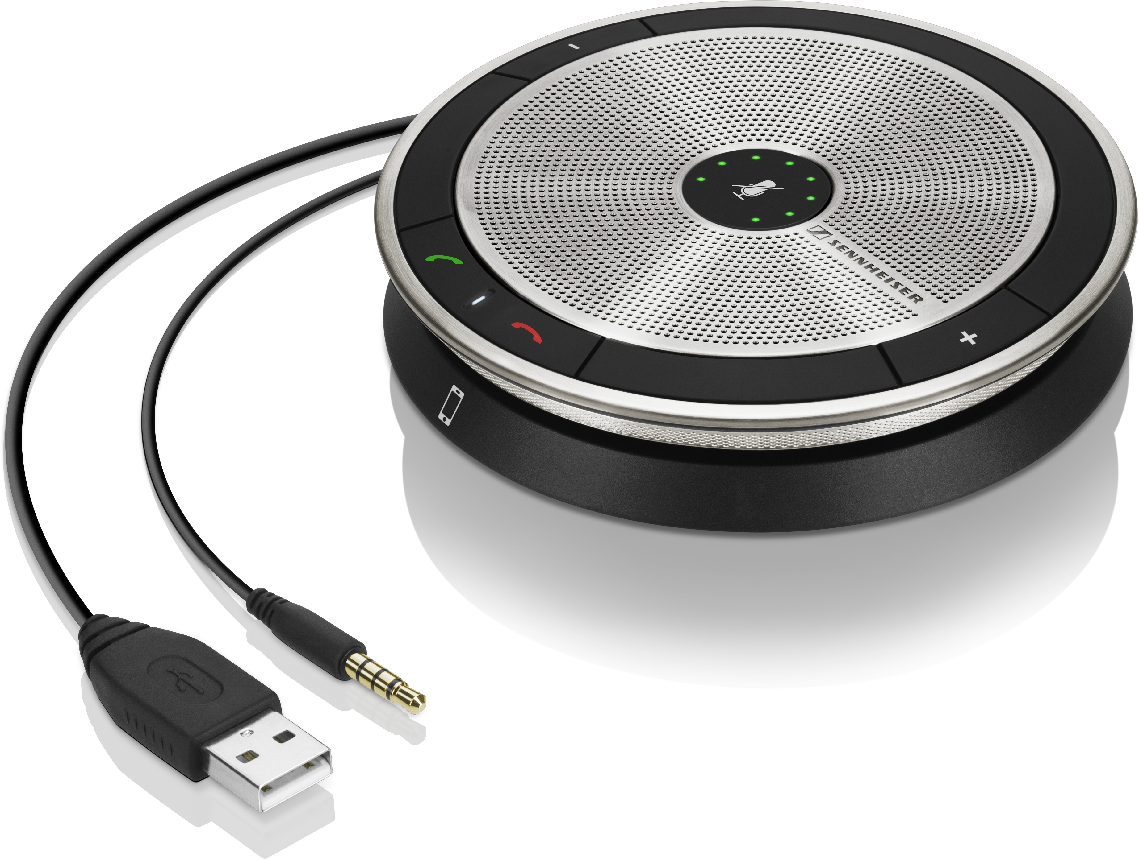
Designed for the mobile business professional, Sennheiser’s SP 10 and SP 20 Speakerphones are lightweight, portable conferencing solutions that facilitate personal and small group conference calls via PC or mobile/tablet with user-friendly ‘plug in and talk’ simplicity and intuitive functionality. The award-winning, stylish speakerphones offer outstanding sound quality, voice clarity and echo cancellation to ensure a natural communication experience for speaker and listener alike.

*Sennheiser MB Pro 2 UC

About ShowStoppers
ShowStoppers produces invitation-only private events that organize company launches, product introductions, sneak previews and hands-on product demos for reporters, editors, columnists, bloggers and industry analysts – trade, consumer, entertainment and business journalists and analysts specifically selected and qualified in advance by ShowStoppers.

About Sennheiser
Audio specialist Sennheiser is one of the world's leading manufacturers of headphones, microphones and wireless transmission systems. Based in Wedemark near Hanover, Germany, Sennheiser operates its own production facilities in Germany, Ireland and the USA and is active in more than 50 countries. With 18 sales subsidiaries and long-established trading partners, the company supplies innovative products and cutting-edge audio solutions that are optimally tailored to its customers' needs. Sennheiser is a family owned company that was founded in 1945 and which today has 2,700 employees around the world that share a passion for audio technology. Since 2013, Sennheiser has been managed by Daniel Sennheiser and Dr. Andreas Sennheiser, the third generation of the family to run the company. As part of the Sennheiser Group, the joint venture Sennheiser Communications A/S is specialized in wireless and wired headsets and speakerphones for contact centers, offices and Unified Communications environments as well as headsets for gaming and mobile devices. In 2014, the Sennheiser Group had sales totaling €635 million. www.sennheiser.com

For more information on our professional headset and speakerphone solutions, please visit www.sennheiser.com/cco or contact:
Sennheiser Communications A/S
Melanie Ibsen
PR Manager CC&O
Industriparken 27
DK-2750 Ballerup
Tel: +45 56 18 0362
Email: Mibsen@sennheisercommunications.com

