Orbit

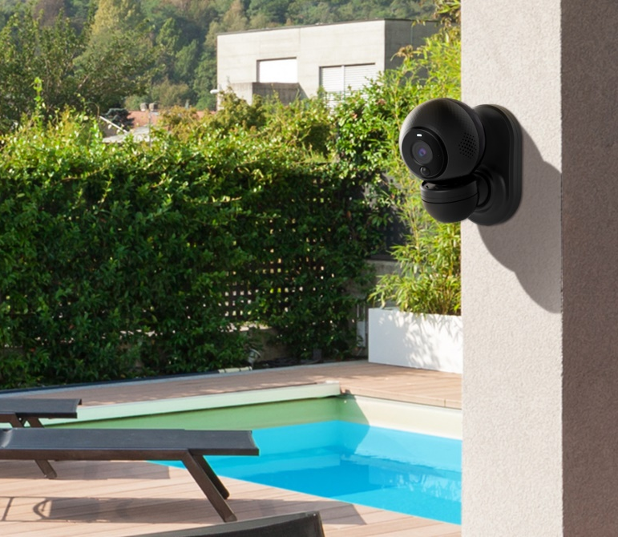
As portable and as flexible as you are
Indoors or outdoors, battery or main powered it’s entirely up to you. Use on battery mode for up to 3 months. Quickly move the camera from location to location using the magnetic mount. Monitor your home no matter where you are, to provide you with peace of mind, 24/7. Check in on your family or pets using your phone at any time day or night using infrared mode. It also as weatherproof as you are as has a IP66 water resistant rating.

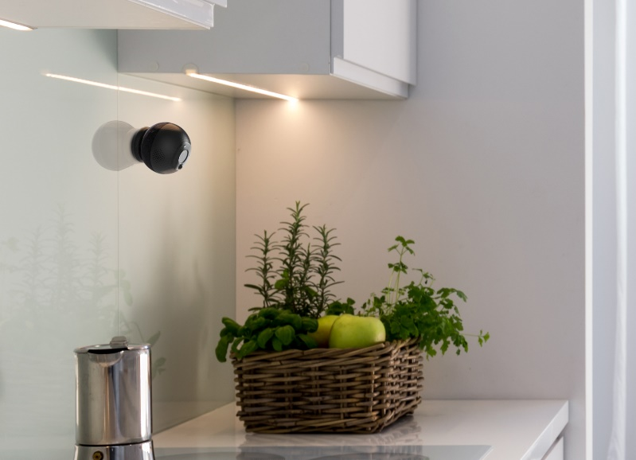
Stream live or playback to relive the moments
Watch in up to 1080p HD quality with the 150 ⁰ field of view. Never miss a moment with the help of the PIR motion sensor that enables motion detected recording to SD card or to the Hubble cloud. Get notified with sound and motion alerts and playback moments captured on the timeline at anytime*

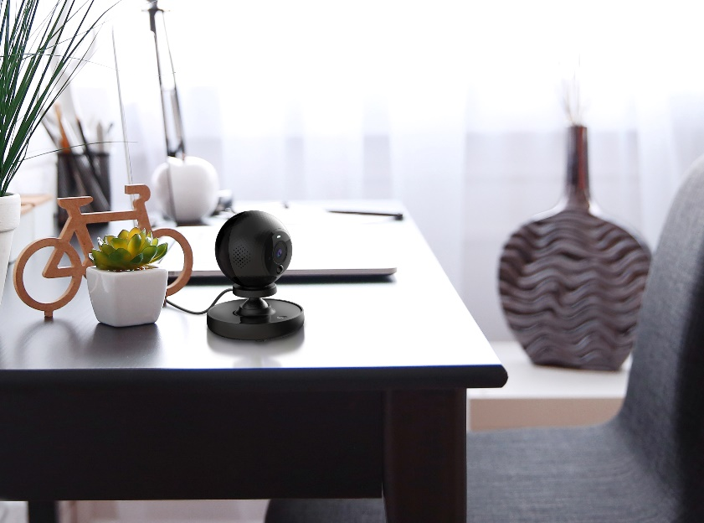
What makes Orbit smarter
Watch out for Hubble subscription service features such as human and zone detection which enable you to distinguish between humans and pets and allow you to focus on a particular part of the room or garden for example a window or shed.
Whether you’re interest in finding when Rex is his most active through day, what time Alicia left for school each day, video highlights from Henry’s birthday party or just to check who’s secretly eating been eating all the chocolate in the fridge… Hubble has the answer.

*requires appropriate subscription plan

