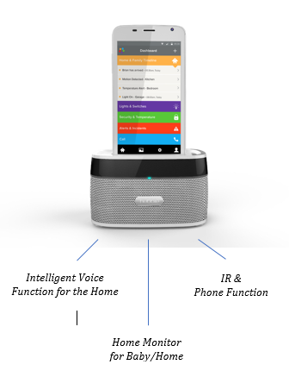
IVO
Smart home viewer
The IVO is a unique HD smart viewer for use with any Hubble Connected monitor or device. Like Hugo, it has Alexa voice control and a host of other apps built in to integrate with other smart home devices, you can even make phone calls or control your TV.

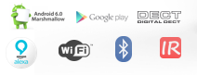
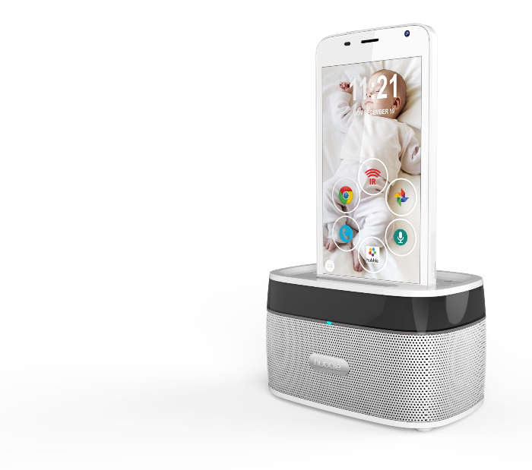
One remote control for the home
Control your lighting & switches, heating, security and Skype or homephone landline calls. Use Alexa in IVO and the Bluetooth speakers to play music and make calls.

4 in 1 smart home viewer
- Screen for Baby/Home Hubble Connected Monitors, works with Hugo and Smart Nursery
- Smart Speakers with Amazon Alexa voice control
- Infrared remote control
- DECT home phone

Technical Features

- 5” LCD / HD 1280x720 / IPS
- Android OS 6 Marshmallow
- Google GMS Certified
- Quad-Core CPU Cortex A7 @ 1.3GHz
- 1GB RAM & 8GB Flash
- 2MP/720p Front Camera
- 5MP/1080p Back Camera
- WiFi 802.11b/g/n/ BLE 4.0
- Micro USB / Micro SD-Card up to 32GB
- Li-Polymer Battery 2240mAh
- IR Remote Control in handset
- Speakerphone in handset
- Charger base with PIR Motion & Temperature Sensor,
- IR Night vision
- Using integrated Cameras for monitoring
- Bluetooth Speaker & Mic in the base for
Voice enabled Operation
- Optional: separate DECT standalone base for PSTN
- Handset dimensions: 144x72.5x8.5mm
- Color: Black/Gray/Silver

