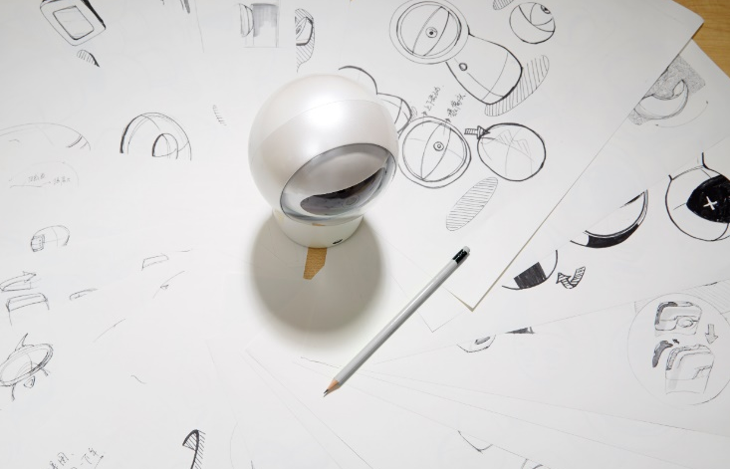
What is HuGo?
HuGo is the world’s first Smart Camera to be launched combining intelligent Voice Communication, entertainment and home monitoring.

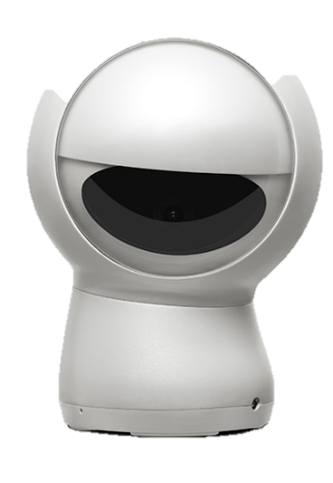
HuGo & Alexa
HuGo comes with Amazon Alexa built in and over 500 apps such as ESPN Sport and Disney Junior. Control other Alexa enabled devices in the home, play radio stations, and entertain the whole family.

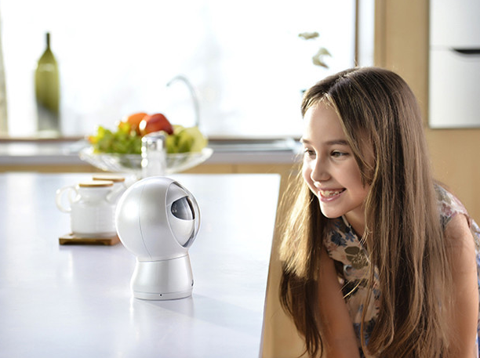
Cute and Funny
HuGo is a fun pal to have in the house. The “eyeball dance” makes everyone laugh. Cute expressions are achieved by 4 high precision motors which drive the eyeball. Eye contact enables HuGo to work out who the person is and how they are feeling.

Entertaining
HuGo is designed with a unique personality and a distinguishing voice. With state-of-art voice recognition engine inside, it can receive various commands like playing the music or audio books

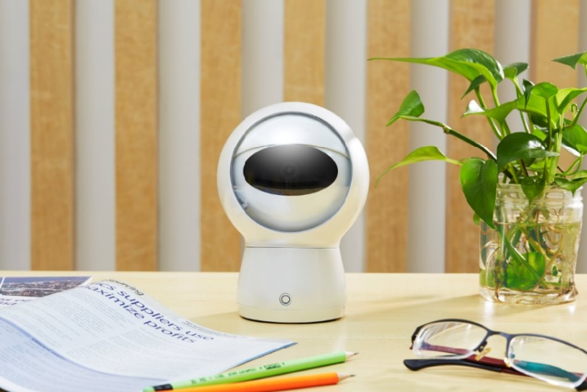
Event Recording
Event recording is now hand free. With facial tracking capability, HuGo can take photos or videos and can also capture the best shot for you!
Up to 1080p high resolution video with H.264 compression, your memory can be either stored locally onto a mirco-SD card, or transmitted over internet to the cloud to view on your mobile phone.

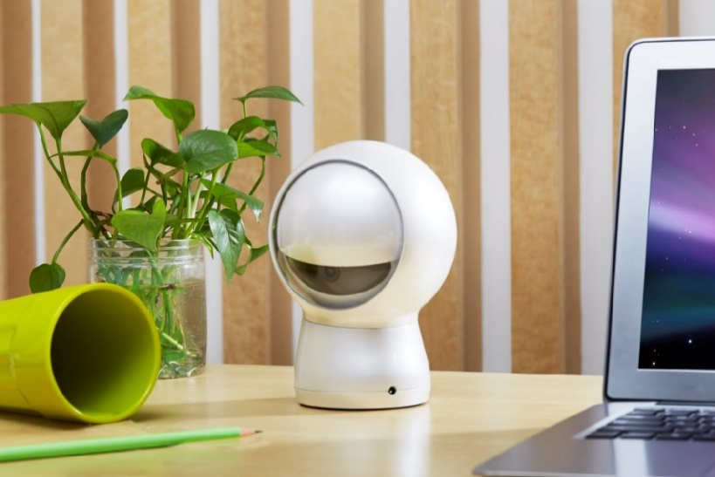
Monitoring
360 degree movement tracking and Peer-to-peer (p2p) connection allows the user to monitor home from anywhere at anytime. The connection is highly secured. Video content cannot be intercepted or decoded.

Personal assistant
You can set alarm or reminder simply by talking to HuGo. With both Wi-Fi and Zigbee wireless connections, smart home controlling becomes so easy. You can also obtain local information easily such as weather or worldwide news from HuGo.

Total Privacy
HuGo has a motorized lens cover which can be closed at the press of a button. Having physical camera lens cover makes it impossible for the camera to operate when you prefer to have private moments.

Technical Features
- AES256 Encryption with SSL
- Quad-Core CPU ARM Cortex A7
- GPU – Mali 400MP2
- 2GB Flash & 256MB RAM
- 2MP/1080p Camera
- 110 degrees wide angle lens
- PTZ function allowing with wide
angle lens 360 degrees view
- 4 high grade stepper motors
- Far field dual microphones with ANC
- WiFi 802.11b/g/n
- Zigbee HA 1.21
- Micro SD-Card up to 32GB
- 3 Watt Hi-Fi Speakers
- Li-Polymer Battery 2400mAh
- Color: white

SlashGear
“Hubble Hugo - Best Imaging Product of CES 2017”

